

NEWSLETTER DATED FRIDAY 12TH SEPTEMBER 2025

Dear Families,

Welcome to the New School Year!

I hope this newsletter finds you and your families well and rested after the summer break. It is a pleasure to welcome you all back to St John’s Catholic Primary School for the start of a new academic year, and to extend a particularly warm welcome to the new families who are joining our school community for the first time.

As a Catholic school, we are proud to place Christ at the centre of all that we do. Our mission is to nurture the spiritual, academic, emotional, and social development of every child in our care. We are looking forward to another year of learning, growth, and faith, where together — school, home, and parish — we support one another in helping our children flourish.

Until we get to Advent of this year, our school theme continues to be celebrating the Year of Jubilee – challenging us to be pilgrims of hope. Through our collective efforts in prayer, service, and learning, we will help our children understand how they can live out Gospel values and Catholic Social Teaching themes each day.

Our dedicated staff have worked hard over the summer to prepare a welcoming and stimulating environment, and we are excited to begin the year with enthusiasm and hope. We are committed to delivering a high-quality education rooted in faith, and to supporting every child in reaching their unique God-given potential.

There will be many opportunities for you to engage with the life of the school in the coming months — from curriculum evenings to school Masses, parent meetings, and celebrations of learning. We deeply value your partnership and support, and we look forward to walking alongside you this year in faith and friendship.

I encourage you to take note of the dates for the diary which are included on the school website and within this newsletter.

Please don’t hesitate to contact us if you have any questions, concerns, or suggestions as the year progresses. Let us keep each other in prayer as we begin this new chapter together.

With every blessing for the year ahead,

Yours sincerely,

Mrs O’Rourke
Headteacher

Foundation Stage Children

It has been wonderful to welcome our Foundation Stage children into school and what a fantastic start they have had! We have been busy getting to know each other, exploring our new classrooms and outside area as well as going on a tour of the school, staying for lunch and having a demonstration of how to use the scooter boards ready to start out OPAL play next week! We are so looking forward to the year ahead.

Please send in any outgrown uniform for Foundation Stage (age 4-5) to have as back ups! Shirts/dresses/trousers/shorts/tights/socks would be gratefully received.
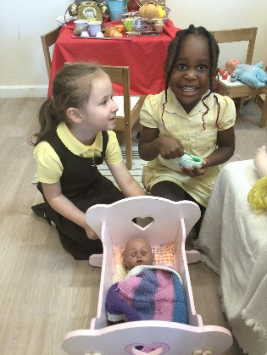
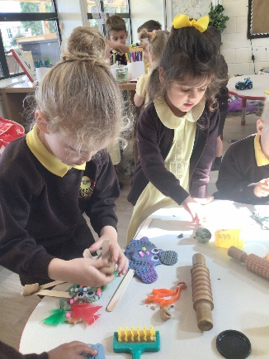
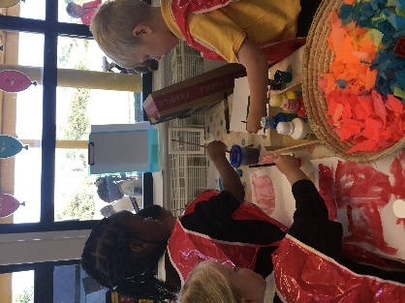

Dates for Term 1

Open Day for new families – 23rd September
Y4 First Holy Communion Mass in school – 9.05am on 23rd September – all welcome
Meet the Teacher workshop – 23rd September
Fairtrade Fortnight – 22nd September – 3rd October
School photos – individual and siblings – 30th September
Y6 Bikeability – Group 1 – 1st October
Y5 Sculpture Park Visit – Salisbury – 2nd October
Friends of St John’s AGM at 7pm followed by chocolate bingo night – 3rd October
Faithfulness Class Mass – 7th October at 9.05am – all welcome
Taize Reflections with KS2 – W/B 6th October
Parents Evening – 3.30pm – 6.00pm – 7th October
Living Rosary Year 5 & 6 – 9th October
Friends of ST John’s Meeting – 3.30pm – 4.30pm in school meeting room – 9th October
Harvest Service in school hall – 10th October
Harvest cereal challenge for Trowbridge foodbank– 2.45pm at 10th October
Parent and Headteacher Meetings – EYFS & KS1 at 9.00am KS2 at 9.40am on 13th October
Year 6 Maths Workshop – 14th October
Y5 Reading Breakfast with parents 15th October from 8.40am to 9.30am
Open Morning for new families – 16th October
Parents Evening – 16th October
Movie night for KS2 – 3.30pm – 5.30pm – 17th October
Car Boot Sale – Saturday 18th October 10am – 12pm
House Saints Afternoon – parents welcome from 2.50pm
EYFS Parents Pilgrimage around school site and EYFS Welcome Service 21st October
End of Term – 22nd October

Upcoming Dates

Mr Adrian Smith’s first year anniversary Mass at St John the Baptist Catholic Church – 4th November – All welcome
Y6 Skern Residential – 11th November to 14th November
Rise Theatre visit – focus on Catholic Social Teaching themes – 12th November
Open Morning for new families – 15th November
Odd socks Dy for Anti-bullying week – 19th November
Christmas Fayre – Thursday 20th November – 4.30pm – 7.30pm
Year of Jubilee Celebration afternoon – 21st November
Class 9 Mass – 25th November
TD Day – 28th November
Y4 Reading Breakfast in school hall with parents – 3rd December from 8.40am – 9.30am
EYFS Nativity in St John the Baptist Church – 11th December at 2.00pm
St John of God Feast Day – 8th March
Sports Day – 22nd May
St John the Baptist 150th Celebration – Saturday 27th June being celebrated at St Augustine’s Catholic College
Summer Fayre – Friday 10th July from 4.30pm – 7.30pm
Parent & HT meetings – EYFS/KS1 9.00am – 9.30am

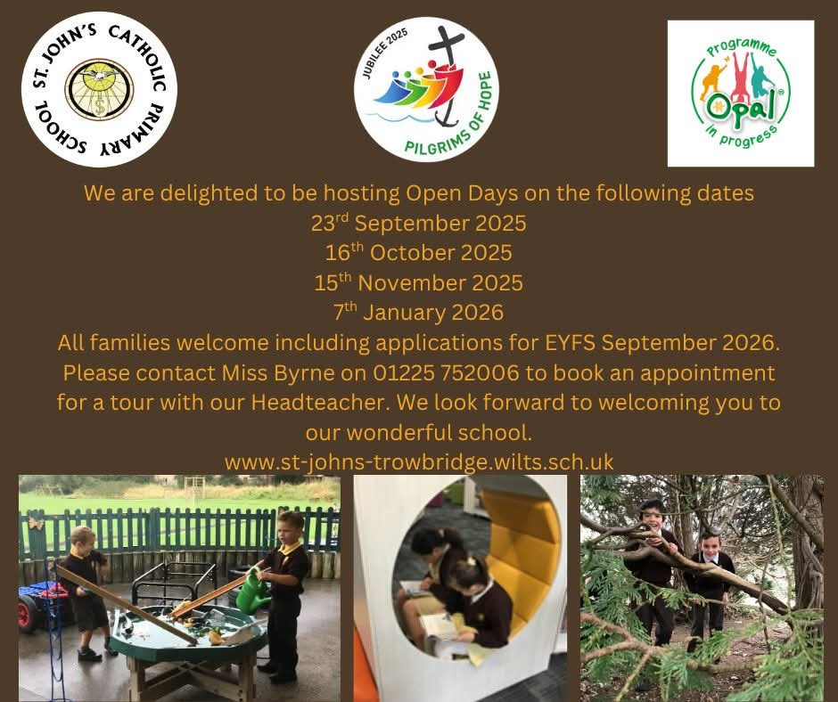

OPAL
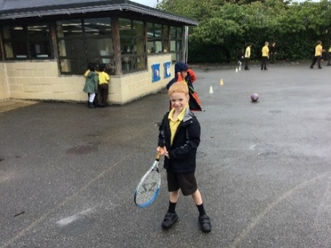

It has been wonderful to see OPAL play back in full swing during our first week of the new school year. The children have returned with great energy and creativity, making the most of the outdoor resources. “I loved playing with my friends again,” said one pupil, while another shared, “It’s fun because we can make up new games every day.” One child summed it up perfectly: “OPAL makes playtime the best part of school!”

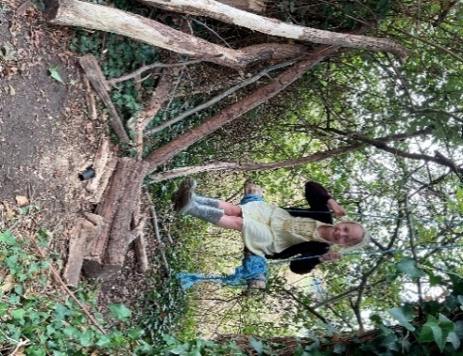

Phonics Books and Worksheets
As part of our phonics scheme, your child will be bringing home a selection of books and reading sheets linked to the sounds we have been learning in class.
Sometimes a book or sheet may be sent home more than once, or kept for longer than a week. Please don’t worry if this happens – repetition is an important part of embedding phonics knowledge and developing reading fluency.
Reading at home should be enjoyable and is also a chance for your child to read with expression and confidence. The texts they bring home will usually be familiar, as we will have already explored them together in class.
We encourage you to enjoy this time with your child and celebrate their reading as they share these books and sheets with you.

Birthdays
During Celebration Assembly or in the classrooms, we celebrated all children who have had birthdays and presented them with a St. John’s birthday pencil.
Pupils
Sebastian H Marta K

Alexander S Agata K
Monty C Aidan N
Jakub S Nell G
Elizabeth D Michael S
Fiorella L Cillian J

Keys Found
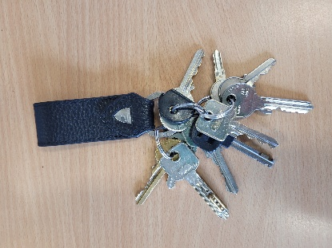
A large bunch of keys have been handed into the school office.
They were found outside the school gates. No-one has
reported them lost. If they belong to you, please come to the office
to collect them. If no-one claims them, we will take them to the Police
Station.
Thank you

Wednesday Word
Please find below the link to this week’s copy of the Wednesday Word which can be copied and pasted into your browser. This week’s word is SELF-GIVING.
https://www.paperturn-view.com/wednesday-word/good-news?pid=MTA101634&v=163.4

Clubs Letter
You should have received the letter on Parentmail listing all the clubs available to pupils in Terms 1 and 2.
If your child would like to take part in any club, please complete the appropriate form by Monday 15th September.
Clubs will start on Monday 22nd September 2025.

Letters to Parents

The following letters have been sent out to parents this week, please ensure you have read the information. If you have any questions Mrs Burden and Miss Byrne in the school office would be very happy to support you.

- Music Lessons opportunity for the new academic year
- Reading and Phonics provision in KS1 for the new academic year
- Mobile phone permission slips for UKS2
- After school club provision for the Autumn term – including new opportunities for a drama class led by an experienced drama Teacher

MDSA Vacancy in the School Kitchen

An opportunity to join the St John’s team has arisen in our school kitchen working with a dedicated team who support our busy lunchtimes. The kitchen team support what is required to ensure all children enjoy a hot meal and packed lunches. The role requires working Monday – Friday from 11.00am – 1.45pm. If you would like to discuss the role further or request an application form please contact Mrs Poulter at admin@st-johns-trowbridge.wilts.sch.uk Please do share this opportunity with family and friends.

Communication with Inclusion Lead

This academic year Mrs O’Mahony – our Inclusion Lead – has ring fenced two weekly slots for parent meetings to ensure families have the opportunity to discuss any issues regarding special educational needs and their child. The meeting times and days can be arranged with Mrs Burden in the school office who can be contacted via telephone on 01225 752006 or email reception@st-johns-trowbridge.wilts.sch.uk A reminder for parents that all initial discussions regarding your child should be organised with your child’s class teacher who is best placed to support.

The New Academic Year

We are excited to invite you to our upcoming "Welcome To The New Academic Year" Workshop, an opportunity for you to get to know the wonderful team who will be guiding your children this year.

Event Details
Date: Tuesday 23rd September
Time: 3.30pm – 3.50pm or 4.00pm – 4.20pm
Location: Your child’s classroom

Join us for:
A warm welcome from the class teacher
A tour of your child’s classroom
An opportunity to meet all the teachers
A short presentation outlining the curriculum overview for this academic year

This is a great chance to connect with our teaching team, explore your child’s learning environment, and gain a better understanding of the exciting year ahead. We look forward to seeing you there and working together to make this a fantastic school year!

Highlights of the Academic Year 2024/2025

Attached you will find an overview of the successes of the previous academic year. It is impressive to recall what has been achieved by the school team and wider community and we look forward to the blessings of a new academic year together.

First Holy Communion Mass in Hall With Parents on Tuesday 23rd September 2025

Children who celebrated the Sacrament of First Holy Communion in May/June 2025 are invited to celebrate Mass in our school hall on Tuesday 23rd September from 9.05am - 10am. All family members are welcome to join us.

On the morning of this day the children are invited to come into school wearing their First Holy Communion dresses/suits/special outfits and will need to change into their school uniform later in the morning. We look forward to gathering together on this joyous occasion as a school family.

Academic Mass for the New School Year
On Tuesday, we gathered together in church to celebrate the start of our new academic year with a beautiful votive Mass for Our Lady. It was a special moment for our whole school community to come together in prayer, asking for Mary’s guidance and care as we begin the year ahead. In his homily, Father Richard reminded us of the importance of turning to Mary in prayer and of leaning on her example of faith, courage and strength in our own lives. The Mass was a wonderful way to begin the year.

New Reading Breakfast with Families

We are warmly inviting parents/grandparents into the school hall on the following dates to enjoy a relaxed start to their day with coffee/tea and croissants with their child and sharing some high quality books together. We look forward to welcoming you into school to share your love of reading and power of the word!

Year 5 – Wednesday 15th October from 8.40am – 9.30am
Year 4 – Wednesday 3rd December from 8.40am – 9.30am
Year 6 – Thursday 15th January from 8.40am – 9.30am
Year 3 – Tuesday 20th January from 8.40am – 9.30am
Year 1 - Tuesday 17th March from 8.40am – 9.30am
Year 2 – Thursday 5th February from 8.40am – 9.30am
EYFS – Wednesday 22nd April from 8.40am – 9.30am

Retirement

After more than two decades of unwavering dedication, our beloved caretaker, Mr. Miller, is retiring from St John’s Catholic primary school at the end of Term 1. His retirement marks the end of an era defined by hard work, kindness, and a steadfast commitment to our school family as well as lots of Mr Miller jokes!

For over 20 years, Mr. Miller has been much more than just the caretaker of our school. He has been a familiar, friendly face in the corridors, a helping hand during every school event, and a guardian of our school’s spirit and safety. His tireless work behind the scenes has ensured that our school remains a safe, welcoming, and well-maintained environment for generations of pupils, staff, and visitors.

Mr. Miller’s role extended far beyond maintenance and repairs. He greeted every child with a warm smile, offered words of encouragement, and was always ready to lend an ear or a helping hand. His presence was a comforting constant, a symbol of stability in the ever-changing rhythms of school life.

As a caretaker at a Catholic school, Mr. Miller also embraced the values and community spirit that define us. He lived out these values daily through his kindness, humility, and dedication, becoming a role model for both pupils and staff alike.

We will be planning a celebration before the end of Term 1 to mark Mr Miller’s contribution and allow the children, staff and families to say their thank you and farewells.

Harvest Service and donations for the Trowbridge Foodbank

Again this year in preparation for our celebration of Harvest – when we reflect and give thanks for everything we have - we will be collecting donations of cereals for the Trowbridge foodbank. Last academic year we managed to collect over 180 boxes of cereal that went to families in our local area who do not have food to support them and their loved ones. Please encourage children to bring in one box of cereal and we are hopeful we can raise over 200 boxes this Harvest.



We are delighted to be working in partnership with Bath Rugby Foundation throughout Terms 1 and 2, with their coaches visiting us every Friday. Their sessions will support our school’s commitment to the Catholic Social Teaching theme of Family and Community, helping all children feel included while developing a love of sport. They will be delivering a variety of sessions to various Key Stage 2 pupils during the school day, as well as run an after-school Tag Rugby Club for Key Stage 2, aimed at building confidence, teamwork and enjoyment of physical activity.


