Geography | Science | PSHE
We are learning about our local area, including the physical and human features in  Trowbridge. Can you take photos or draw images from the places around us that you visit and decide whether they are physical or human?  https://www.bbc.co.uk/bitesize/articles/zr8q7nb  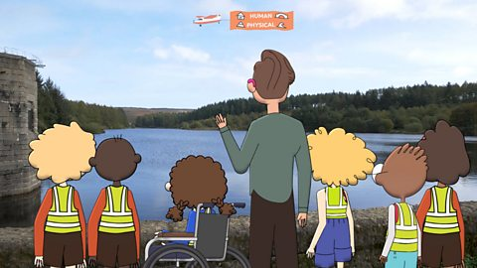  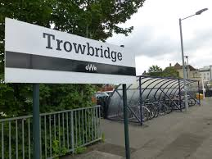 | 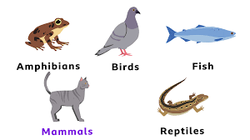  We are learning about animal needs for survival. Within that, we are re-capping animal classification and learning about what each needs to survive.  Can you design and invent your own animal? Just like the platypus, which is a mammal that lays eggs and has a beak, can you try to make it have features from all the groups?  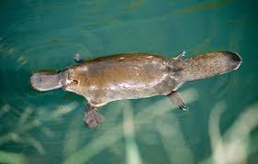 | https://www.youtube.com/watch?v=aSFvJbSQdA4  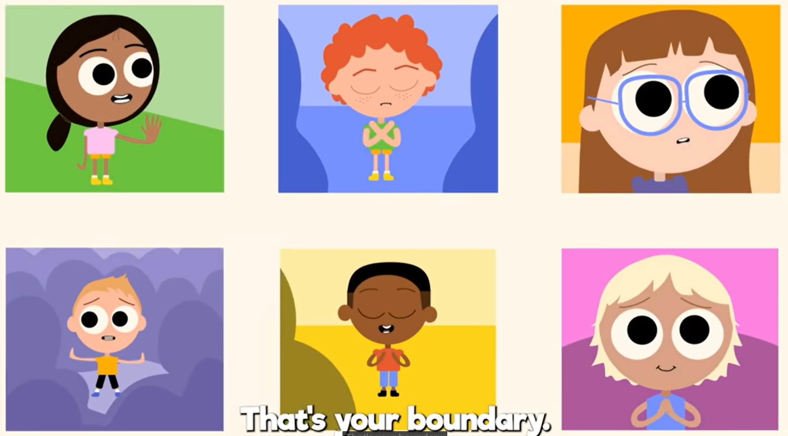  We love this song in KS1! So do listen at home and re-iterate the messages – if something is happening that you don’t like you need to say something.  We’ve also been learning about new beginnings. Can you make a poster about your favourite things in your new class? You could write or draw your new friends, fun toys or exciting learning activities.


