This term we are learning about Kenya in geography.  Children could create leaflets all about Kenya, including maps, pictures and facts.  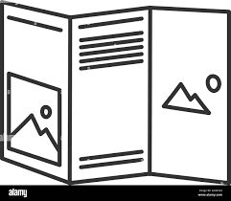  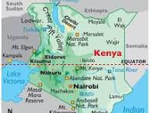 | We will be learning about the Great Fire of London in History.  We will learn about what happened, when it happened and key people involved.  Write/word process a diary entry from an eye witness experiencing the Great Fire of London describing what happened to them during the fire. Start from Sunday morning 2nd September 1666 and finish on Thursday 6th September. 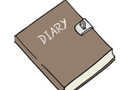  Make a fact file about what London was like in 1666. What were the houses like? What jobs did people do? What equipment was used to put the fire out?  Make your own 2D/3D Tudor house using materials of your choice.  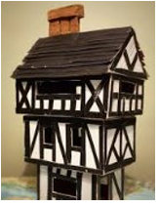 | In Science, we will be learning about the properties of materials  Go on a "materials hunt" around the house to find examples of wood, plastic, glass, and metal. Can you sort them into categories and label their properties.  Make a poster about them.  

