This term we will be looking at Living Things and their Habitats in Science.  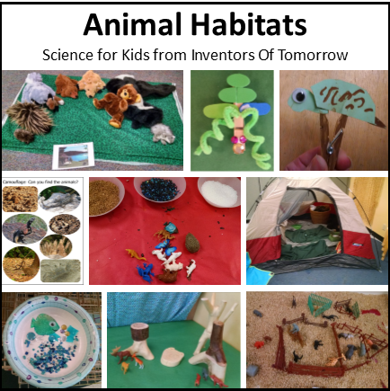  Choose an animal and find out about what their habitat would look like. Can you draw it or make it using things you have in your house? | In Geography and History, we are continuing to look at Kenya and The Great Fire of London.  Can you choose one and create a poster all about what you remember or can find out?  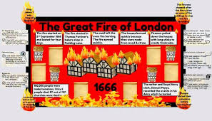  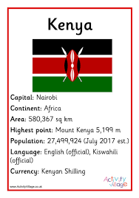 | We are continuing to develop our writing skills and will be writing stories based on stories from other cultures.  Can you choose a character and write a story about them? Don’t forget to use finger spaces, capital letters and full stops!    

